Zurich, 27.11.24
Dr. Thomas Dursch
Chief editor, Nature Chemical Engineering
Subject: Revised NATCHEMENG-24061044
Dear Dr. Dursch, dear Tom,
Thank you for your decision on the manuscript, now titled ‘Towards green acetylene synthesis and application’ by Z. Zhang, A. Nabera, G. Guillén-Gosálbez, and J. Pérez-Ramírez, and for the opportunity to submit a duly revised version to Nature Chemical Engineering. We are delighted by the positive feedback from our peers and the editorial team, and we have thoroughly addressed all the points raised during the revision.
As agreed, we have revised the format into a Perspective (with a review component) to emphasize the forward-looking vision of renewable acetylene production. Additionally, we have modified the title, clarified the objectives in the introduction, and shortened Section 2. These actions sharpen the focus on the unique aspects highlighted by Reviewers #1 and #3, while addressing the primary concern of Reviewer #2. We appreciate your exception regarding the length, which we have respected in this revised version.
With regard to the comments from Reviewer #2 and #3, recent advancements in acetylene applications, including electrocatalysis, photocatalysis, and thermocatalysis, have been incorporated into Section 3. Additionally, data on the projected availability of renewable feedstocks, such as biochar and biomethane, by 2050 have been added to Section 4 to address concerns about resource availability raised by Reviewer #2. These revisions critically analyze current challenges and propose a sustainable pathway for acetylene production and application.
We remain convinced that this Perspective can inspire a shift in research efforts toward renewable ‘building blocks’ for the chemical industry, particularly revitalizing the production and sustainable use of acetylene. Please find attached our responses to the Reviewers, along with the revised manuscript and supplementary information, both in clean form and with marked changes.
We look forward to your decision.
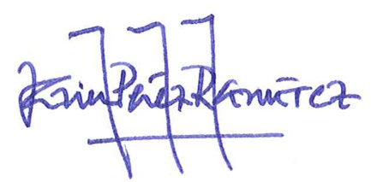
Best wishes,

Javier Pérez-Ramírez

